The Trinity of Search, Security, & Compliance
For
Enterprises and Extraprises

PC-REF-12/31 -2
This document is PointCross Proprietary
USE: For review by partners and advisors

Real Roles – The essentials for search, security, and compliance
People spend as much as 75% of their time in tacit interactions in knowledge intensive businesses according to McKinsey & Co. Their activities include communicating, finding, sharing, developing insights and making decisions from less than perfect information, assessing and applying judgment. Their work products are dispersed among emails, documents, reports, presentations, blogs, and some semi-structured information.
According to the American Records Management Association, the average user spends the equivalent of 1.5 to 3 workdays a month searching for documents. It is easy to see why people need to find not just moth-balled records but content that is work-in-process. Often it is emails, rather than the documents in various content management systems, which are of interest. But how does a search engine know if the email written by a colleague somewhere in the organization can be shown to a user who is looking for that information?
Information and intellectual property is the most valuable currency of a knowledge business. Almost all of that information is in digital form in emails, documents, data sheet and data bases – all of it moving rapidly across networks. As a report or analysis is being worked on its authors need ready access to the drafts, yet it may not be made visible to others in the off chance that partially developed information may be acted upon. Hours later the same document may be available to more people who will review it, and the moment it is published many more people may be authorized to find it and use it. How does a system ensure that every email, document or data is accessed only by people or other systems only when they are authorized to access them?
Compliance is not an option for businesses it is an essential part of business continuity and health. All indications are that cost of compliance is increasing out of control in part due to the cost of records management and in part due to the cost of eDiscovery and litigation support. Global companies in some industries need to comply with tens of separate sets of laws and regulations concurrently. How does a system ensure that as people go about their business activities their business communications and work products are subjected to all the relevant rules without creating additional distraction to their work?
These three elements – search, security, and compliance – are essential to business but they represent an indirect cost on the creation and delivery of value added services. According to studies, 75% or more of a business’ information is transferred through emails. That means that search and communications is the bulk of interaction costs. It makes a lot of sense to make emails, search, security, and compliance much more effective while making them simpler and consume less productive time.

Barriers to simplicity
The development of enterprise software as an industry occurred in parallel with the evolution of computers, networks and software applications. Unfortunately for knowledge intensive businesses which have become a significant part of many industry verticals, the enterprise software industry has been attempting to address tacit interactions with the same legacy tools that served transactional and transformational business – where data was structured, and all core business activities were conducted within the formal functional organization. Habits of practice and thought have conspired to create a number of barriers to simplifying the way business information can be organized and communicated while making search, security and compliance easier and more effective, and less expensive.

Nature of Business Organizations in Enterprises and Extraprises
Formal organization charts define the structure and the titles assigned to people in management and operations of an enterprise. Every employee in the company is mapped into their corresponding title and their job functions are well defined by them in transactional or transformational businesses. Knowledge intensive businesses, like upstream oil and gas exploration and production, Pharma R&D, defense technologies, investment banks, and consulting companies, on the other hand execute and mature a steady stream of projects, deals, or assets while generating value from each one of them. This project or mission orientation is natural and essential because each of these teams consists of people with relevant knowledge, and with the capability to be accountable for the outcome of the project.
Project teams and the project managers are accustomed to treating their project as an isolated island of activity within the larger business, and all project information and activity are usually managed by project management tools for cost, schedule and other PMBOK dimensions. Corporate governance, security and identity management issues give way to project specific governance charters which at times are “fit for purpose” sometimes because of the multiple external stakeholders as in the case of Joint Ventures in the oil industry. Increasingly these businesses are acting globally with numerous external stakeholders that are part of an extended web of project participants. Working on a common project does not imply that a one partner has access to the information owned by the other partners. To ensure that this does not happen, projects get even further isolated out of security concerns – thereby creating even more complexity, and less assurance that security and compliance by each of the participating companies is being adhered to rigorously.
The reality is that knowledge enterprises run three different types of organizations concurrently – (1) The Formal Organization; (2) The Real Organizations or Contextual Networks; (3) The Informal Organization or Social Networks. Real Organizations for projects create and use most of the content in an enterprise or extraprise.
Only the formal organization is treated with enterprise wide identity management and security related permissioning systems. The real organization, its structures and its “Roles” represent each and every project, deal, or asset. These real organizations are not represented in central directories, and each application must manage its own ACL (Access Control Lists). This is where current systems breakdown and make search, security and compliance impossible to simplify.
The popularity of social networks in the consumer, school, or private environment is causing people to consider the same within enterprises. Recognizing the importance of social networks in globally dispersed organizations is long overdue and enterprises are considering incorporating devices like wikis and blogs as well as social networking software to map connectivity of people. But, these P2P social networks can pose a security and compliance risk if they are not contextually controlled. Consider some of the institutionalized barriers to simplicity.

Confusion between perimeter and information security
Authentication and identity management is the first line of the security system in a corporate network – and rightly so. The Active Directory (AD) or LDAP systems then provide services to corporate facilities and applications so that they can allow users to use those facilities. However, beyond authentication of the service requests from individual users or web services seeking information or access to the tools, applications need to know if the particular user has authorization to access that information. Authorization has to do with the business user’s need-to-know when accessing information through any application. Since Real organizations are not mapped into the AD there is no way to ensure this need-to-know without the context in which the user is seeking the information. Today each application needs to be outfitted with an ACL in order to attempt this validation – and it simply does not help in servicing search requests. Moreover, trying to ascertain which rules are applicable for security or compliance based on the content or application is also impossible. The business context is central to making this happen.
AD is fine for managing perimeter security and authentication. A service that can either augment AD with Real Roles and their permissions contextually is vital for search, security, and compliance. The limitations of AD and ACLs are a severe barrier to simplifying search, security, and compliance.

Orphaned business contexts and activities
The result of Real Organizations and roles for projects and assets not being treated with visibility at the corporate AD level has meant that projects teams such as in a E&P company end up with a large number of silo’d areas where content related these projects get stored – orphaned, neglected and not re-used. Any re-use happens because of informal relationships and individual memory – not institutionalized memory. There is no way a search engine can be allowed to index these documents or emails because there is no context around which this content is rallied. Even if this information is in a corporate server, they might as well be squirreled away in someone’s personal file folders.

Application Centricity
IT organizations provision enterprise applications to their users. Over time this tradition has hardened into a application centric view of enterprise information and governance that causes all permissions and provisioning to be managed purely in terms of the tools and their content rather than the context in which the tools need to be used. In reality, tools are only a means to an end for members in a Real Organization; and content is a byproduct of the work done with the tools. The “ends” are the business contexts related to each of the projects and their tasks. Today, there is no way to relate these business contexts to the application use, or its resulting content. In fact, if it were not for application centricity, all types of disparate information related to a business context would be co-related and organized contextually. Not doing so means that instead of applying the rules for access which is required for search and security; or applying rules for how information should be distributed and retained which is required for security and compliance; business users have to spend elbow grease to take each type of content and “put it away properly”, in addition to annotating it with metadata and such. The total work related to this type of interaction can be reduced to a small fraction in an instant.

Business ontology system & services – a contextual provisioning and permissions platform
A simple way to deliver a comprehensive search, security, and compliance capability that can react in real-time is to create a team, departmental, or enterprise level service that is driven by an ontology engine. Ontology maintains the relationship of business contexts that are defined for any activity of any project at any level in the Real Organization or even the functions in a Formal Organization as well as the interrelationship among them. It maintains the contexts for the Roles, People, and Semantic definitions of terminology.
The ontology engine provides a range of services to users and other applications accessing it through web service requests to provide:
- Permissions to access applications and content related to an authenticated user or application through the AD or directly to a registered application,
- Users who search through email, documents, meetings, and business events with search results that they are permitted to see and in the context in which those results reside
- Automatic application of business rules that relate to security or compliance at each context so that the content within them, or even applications required in these contexts are provisioned, distributed or retained according to the rules.
The business ontology system and services has been shown to:
- Dramatically improve the communications and collaboration within a global enterprise or extraprise with security and compliance
- Enable search and re-purpose information securely in real time while keeping a single copy of every email, document, data, or meeting notes and other business content
- Simplify eDiscovery and litigation support by simply selecting contexts that relate to a legal matter and change their access, lock them out, sequester them, or place the associated content into a digital vault.
The ontology engine or business information framework (BIF) as defined by some can dramatically simplify search, security and compliance while also reducing the total cost of provisioning application licenses and providing secure access to content by users. It can be the ultimate bridge connecting business and IT.

This page intentionally left blank.

Roma, Amit, and other readers at PointCross: The following material is for reference. I am attempting to create 4 page punchy document out of the longish document called the “The Nature of Organizations in Enterprises and Exterprises”

The Nature of Organizations in Enterprises and Extraprises

“Companies will increasingly need to deploy technology that makes shared data, information, and expertise available in real time; to offer decision support tools that help workers involved in tacit interactions create insights from data and analyses and that enhance the context and information that interactions require; to improve the ability of employees, customers, and suppliers to interact; and to offer effective collaboration tools for multiparty work flows” .
McKinsey, 2006, Competitive advantage from better interactions, Scott C. Beardsley, James M. Manyika, and Roger P. Roberts

Tacit Interactions Intensive Businesses

Knowledge intensive, decision centric, and project oriented companies are fundamentally different in the way their organizations work and in the nature of business interactions among their departmental employees compared with transactional (Scott C. Beardsley, 2006 Number 2) organizations such as trading or banking enterprises, or transformational businesses such as manufacturing, refining, agriculture or food processing. These knowledge intensive businesses (exemplified in industries such as Upstream Exploration and Production (E&P) of resources such as oil and gas, or innovation intensive Pharma R&D, investment banking and insurance, high technology defense, and the intelligence and security communities) engage in “Tacit Interactions” in as much as 80% (Patrick Butler, 1997 Number 1) of all their activities.
McKinsey’s research, cited here, provides a thorough description about the nature of tacit interactions. However it is interesting to consider the evolution of transactional and transformational businesses from an information flow and information technology view point and compare it with how tacit interaction heavy businesses are being improperly served for the most part when the same organizational models or information technology are transplanted into tacit interactions heavy environment.
In our opinion, a major reason for this disconnect between current application of IT and the needs of tacit interaction lies in not paying attention to either the nature of organizations or the concurrent existence of three disparate types of organizational structures that operate within such enterprises and occupied by the same people. The result, as we see it, is far reaching:
- It makes it unnecessarily difficult to manage permissions and access to business information in real-time across the enterprise
- Difficulty and expense in governance assurance of policies, security, and compliance through the application of business rules – makes search, security, and compliance difficult
- Blind spots when executing specific projects and assignments at the task level where decisions that affect security or compliance are made
- IT systems ignore most, if not all, specific business contexts in favor of tools or applications for a function.
- Current IT environments tends to inhibit collaboration, innovation, and ideation
Let us consider what these disparate organizations are and what role they play in these tacit interaction heavy enterprises. These disparate organizations that we refer to are staffed by the same people, let us also consider how they work within each of these organizational models to use and distribute information in the course of their activities, and what kind of access and discovery services they would need.

Organizational Structures
We recognize three separate organizations that exist in parallel. Most people in these companies will have a place in each of these organizations at some time or the other.
- The Formal Organization
- The Real Organizations or Contextual Networks
- The Informal Organization or Social Networks.
All three are important and each plays an important part in the governance and running of the company and its decision making process. However, not recognizing these very disparate organizations for their differences or serving their business purpose in making projects, and strategic, or planning decisions effective is currently damaging the way information is being organized, managed and made available within enterprises. Although the nature of tacit interactions has been written about in the industry (note McKinsey’s work (Patrick Butler, 1997 Number 1)) over the past decade they articulate a few persistent themes:
- A bipolar view of a formal organization and a naturally evolving social network that needs to be either fostered or brought into the fold of the formal organization
- A view of corporations as an organization of people interacting within a people network (Lowell L. Bryan, Q4 2007) and the need to formalize informal social networks
- An IT and vendor driven application centric view of information and how it relates to the flow of information managed by users for collaboration
None of these models attempt to take a holistic and comprehensive view of how exactly companies actually organize themselves. The glaring omissions are the business contexts – or the business topics. Enterprises exist to serve their customer base for the ultimate benefit and the creation of value for their own shareholders. All the organizations of the company are means to reduce the total cost of transactions (Coase, 1937) that are required to execute the purposes of the business. But yet, there is no discussion about introducing the business context – or business purpose driven topics that drive the work of people - and the dynamic networks of these contexts – or raising the consciousness of the cost of transactions to complete these contexts. Instead the discussions are currently stalling around intangible concepts such as collaboration.
We will describe an organizational model that takes a holistic view of the firm and its purpose and how it can be represented by a tightly coupled system of Organizations, People & Roles, and Business Contexts. Such a model will display hierarchy for certain purposes such as governance, control, compliance and security; while it is also a set of dynamic networks of contexts and people that work to complete the purpose of the firm.
Vendors, analysts, and IT management may understandably find it difficult to step back and address the implications of less tangible organizational structures than the “Formal Organization” depicted in the published “organization chart”. This is particularly true when the formal organization is tied too tightly to authority and authorization by way of the Active Directory, or to the access to content through ACL (Access Control Lists), or even Compliance related declarations and reporting.

The Formal Organization
The management of the company defines the formal organization with its ubiquitous organization charts. It is well known in any company. Management uses it to express the command and control structure of the company and how governance is assured in the company. The hierarchy defines who one reports to; and the direct reports if any to each employee. It also identifies the roles that have accountability for certain business functions. A distinguishing aspect of roles in the formal organization is that they represent “general” corporate functions and but never a specific instance or one’s role in it as it relates to a specific project, a deal, a task, or a committee. A person in the formal organization chart may have one or more “Titles” or Role(s).
Companies may execute their business along the lines of a functional organized hierarchical chart. Others may execute as a matrixed organization where cross-functional structures are created to manage large assets or programs. Yet others may have organizations with multiple dimensions along regional, program, or business units. All of these form a part of the formal organization.
The formal organization is almost always well defined particularly in publicly traded companies, and every re-organization in these companies causes changes to the organization chart that propagate across to the people that are affected. The Active Directory and identity management systems capture these structures and the formal designations and the zones of responsibility are clear and available.
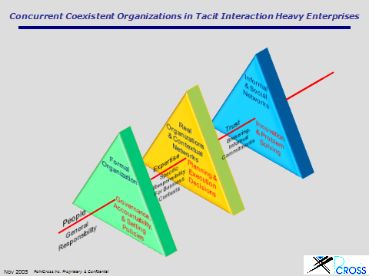
The “Roles” associated within the formal organization represent the functional responsibilities as well as title and the points of accountability for each functional stream. From a management point of view this ensures business continuity besides providing a mechanism to ensure that the will of executive management can be asserted to fulfill their fiduciary responsibilities to their stockholders.
The IT organization mirrors this formal organization into its “AD” (Active Directory (Madhavan, 2007)) of roles and people assigned to those roles, combined with an authentication system to identify people and match them to their AD identity. Centralized software applications of a decade and more ago were run by EDP (Electronic Data Processing) people until the age of intra-nets, when each application had its own set of authorized access lists. The Active Directory was a major step forward in securing the perimeter of the corporate intranets and granting users authorized access to applications, data and facilities using the latest and current organization charts.
Formal organizations rarely if ever show any propensity for network like behavior. People are, after all human beings, and a modicum of give and take does occur among people on a personal level, but formal organizations are generally very structured hierarchies, and carefully devoid of ad hoc networking behavior. The nature of interactions among people, while assuming their formal roles, will understandably be formal, informative as opposed to collaborative, and related to governance or policy rather than specifics.

Real Organizations
Real organizations, as we define it, are the organizational structures used to execute specific projects, joint venture programs, deals, or even tasks and any business activity which are not explicitly covered in the formal organization. An alternate name for such an organization could very well be “Specific Organizations” to underscore the transient nature of these organizations as they get created for each project as it begins until it ends.
A company plans and executes countless projects in the course of running its business. These may include:
- Capital intensive build outs,
- Projects in R&D or product development,
- Asset maturation projects,
- Supporting projects and services such as drilling and seismic data acquisition for exploration and exploitation projects;
- Setting up studies for clinical trials and contracting research organizations as part of a drug development programs and others.
In fact, in knowledge intensive, decision centric organizations where tacit interactions are the norm (McKinsey & Co. 2006, Competitive advantage from better interactions, Scott C. Beardsley et al,) these activities consume all the time of the knowledge workers. These activities are essential components of the intent behind the formal organization. It is just that to execute them, the company needs a focused team assigned to each project or activity and they need to be able to work towards completing those mission objectives.
It is not clear why the real organization never gets mapped or managed even though most of the material decisions of a tacit interaction heavy company occur within them. We speculate that it is possibly because of the disparate types projects and deals making it difficult to use a common system; the attempts to apply collaboration as the end all and be all for such activities; the granular and dynamic nature of the roles and contexts within each project; the large ever growing scale of the fine grained contexts; or the documented lack of mind share between IT and regular business users. We propose that Real Organizations have a “dual nature”, which like light (light is considered to have dual nature by manifesting behavior of wave propagation as well as those of particles in motion) has a dual nature – a hierarchical organization or structure of roles (OBS – Organization Breakdown Structure) for executing the specific projects (usually a tailored version of a templated organization chart); and a network of business contexts consisting of the project tasks (WBS – Work Breakdown Structure), system breakdowns, contract structures, interface management structures, or component project structures (for large programs). Since most real projects are interlocking or interdependent, these real organization structures or trees end up getting connected at different levels to form the company’s ontology.
Material decisions are almost always related to a specific deal or project or a committee action from the leadership level to the detailed tasks related to each of these specific projects. Every project, deal, asset or task has explicitly or implicitly defined roles occupied by people who execute them with the responsibility that the roles define. These roles need not have a direct relationship to the titles, or roles, of the formal organization. But these roles are very important because this is where the real work of the firm is done. Therefore these are the roles that truly matter for compliance and information security. Each of these projects, deals, assets or tasks have their organization charts that can be treated as a self standing formal organizations of the specific real project. In the course of the operations of the firms these real projects will be constantly spawned as the need arises, or continuously if there are processes such as asset maturation or drug development process. Think of the real project as a single “instance” of a class of projects considered central to a company’s purpose. An oil exploration company will, for example, need to acquire assets which it will mature through exploration and exploitation. A specific project, say Block 919 in the Gulf of Mexico, on the other hand is a Real Project.
Typically each of these projects has their own leadership such as a Program or Project Manager, and a team with assigned roles and responsibilities. The assignments are done through a RACI (Responsible, Accountable, Contributor, and Informed) assignment and project specific roles (e.g. Reservoir Engineer, Geologist, Scientist, Regulatory Liaison, Toxicologist). A specific individual, John, who may be a Geologist and recognized as so in the formal organization may work alongside ten others with the same designation. However John may work on Project X as a Geologist, while on Project Y he has no involvement. This is major point of failure in using the AD to drive access privileges to specific applications or data or content.
Here we find that the formal organization and their designation to have limited if any value to the project organization where the assignment of John as “Geologist of Project X” differentiates his role from the other Geologists in the company. We consider the composite of all real organizations of all such projects and tasks assignments – such as the ad hoc assignment of a report to be prepared by an administrative assistant for a manager – to be the Real Organization of the company. The cross functional organizations for real projects in a “Matrixed Organization” are the same as those included here in Real Organizations. The only reason for even marking a difference between real and matrixed organizations are that matrixed organizations contemplate specific categories of projects such as capital projects, or asset maturation (drug development, or exploration assets in oil and gas, or an IPO deal at an investment bank). In reality, there are a whole host of small ad hoc assignments such as internal committees, focused task forces, professionals assigning work to assistants and such. Many of these are charged to overhead and may never see the light of an ERP budget line item – but projects they are nevertheless.
Some of the implications of the roles in the Real Organization include:

- There are clear reporting and accountability chains in each of these real projects that are different from the functional reporting chains (just as a matrixed organization would)
- The information being created and delivered within each project is separate from that in the other projects until such time that they can be treated as a “record” at the project level.
- Dynamically changing information such as documents in the early stage of authoring or approvals, work-in-process content are especially localized to these real projects. Therefore:
  - People in other real projects may not be allowed to see, find, or access such content unless they are expressly allowed to, or if the project leadership decides to make their unpublished content public within the company.
  - The communications by people, on behalf of their real roles, in each of these real projects are critical to the progress of the project, but of considerably less importance to the enterprise at large.
  - The information used and created in the course of the real project is an integral part of the records belonging to the project and they inherit the overall attributes of the project.
  - Real projects have deliverables that are consumed or utilized by other real projects or by external parties. They will also consume deliverable from other projects and external stakeholders. Therefore there are roles within real projects that are subject to the security and compliance at both the project and at the corporate level.
- All work done in each of the real organization is related to a purpose or a business context, and each of these contexts are related to other higher level contexts or purposes, while they may be dependent on smaller lower level contexts. The resulting structure is a hierarchy of contexts that form a contextual structure. Individual contexts may be connected or linked to other contexts in other structures or even other contexts within the same contextual structure. The result is a network of contexts, where each contextual structure represents a concentration of activity.
- Contextual networks are dynamic – they will constantly show hot spot of activity that will ebb and decline and flow information to other parts which in turn will rise in activity. Time and completion of specific purposes in these contexts will determine the lifecycle of these contexts.

A major global enterprise will have thousands if not tens of thousands of projects, deals, and other specific purposes active at any time with hundreds of thousands if not millions of contexts. Each of these projects and deals will have their own organization charts and these contexts naturally form dynamic networks. This entire system is the Real Organization.

Informal Organizations & Social Networks
A third type of organization that must be considered within tacit interactions heavy organizations is the much talked about social networks, also referred to here as the informal organization. Informal social networks are very important because:
- They tap into the natural affinity of people to others who share their interests;
- They are of help to people on matters that require disparate skills or specialized knowledge – something that is vital in complex projects
- They enjoy their relationships and work very well and collaboratively with the others in their network.
Companies are trying Wikis, internal blog sites, and Communities of Practice (CoPs) and studying the psychology of its users and their participation (Lowell L. Bryan, Q4 2007). Communities created to foster one or the other common interest have had mixed results. The improvement in collaboration by formalizing these networks or bringing them under some kind of control must be recognized. The techniques of identifying brokers and connectors to foster such relationships are also being studied and understood. However, it is the trust based clustered networks (which most employees have) which are of interest in this context. These are not the CoPs or blogs or wiki sites where people contribute in inverse proportion to their inhibitions and in direct proportion to available time.
Unlike formal organizations where the Role (Title) is all important and significant; or real organizations where project specific roles are important just as the network of business contexts are important; social networks are simple people to people networks. Roles are not important but expertise is important; and this view point is in disagreement with (Lowell L. Bryan Q4 2007), but we believe this is only a difference in semantics because we have teased apart the real organizations which incorporate projects such as the work of a committee. Other attributes that are important include trust, and the level and nature of the relationship of an individual to the others.
The last Columbia shuttle mission in Jan 2003 disintegrated during re-entry, killing its seven member crew, because its thermal shielding and left wing were damaged and exposed to intense heat. The CAIB - Columbia Accident Investigation Report (Board, August 2003) illustrated the clash between the formal, real, and informal networks. The damage occurred during lift off when a chunk of foam broke off and hit the wing at a velocity of over 500mph. In this case there were two “Real” organizations – the STS-107 mission under way with Columbia; and the Mission Management Team that had the responsibility for also getting the next STS-108 mission underway. These real organizations among others had power through the authority vested by the formal organization. They used the power of formalized authority to win over the correct assessment of the informal, or social, network of thoughtful and concerned people when the Mission Management Team leadership systematically ignored the requests to reconsider the damage to the shuttle wings from a piece of foam at lift off; and to attempt to investigate it before letting the shuttle land. There was also a clash between two “real organizations” that of the current STS-107 and that of the next STS-108 which needed STS-108 to be completed and done with – which itself is an interesting side note about the risks of local optimization.
The formal and real organizations follies around Columbia were not just a show of arrogance or idiocy but a fundamental organizational failure to listen to the social network driven insights that could have, should have, and would have saved Columbia, and the earlier Challenger shuttle. The CAIB report exposes some interesting insights into the nature of organizations. The very same failures in listening to its own internal voices have also been a major contributory factor to the personnel problems and excessive costs and delays in the manned space programs at NASA compared with its sterling performance at the unmanned programs at the Jet Propulsion Labs.
Large global organizations as well government and defense technology organizations tend to rely on a web of contractors and vendors to achieve their business purposes. That brings up the issue also of the nature of these 3 organization types as they function across corporate boundaries. The earlier Challenger shuttle disaster was interesting because it demonstrated that the Real organization – that of the assembly and launching of a shuttle is a multi-party event that is joined at the “Real Organization” hip. Secondly, the social networks within Morton Thiokol that knew of the risks of the “O” ring at freezing or below freezing temperatures did not have sufficient links into the corresponding social networks within the NASA launch team’s “Real Organization”. Had there been such a link, whether it would have made any difference is also unclear, given that ham fisted managers run real organizations with their procedure and schedule books rather than understanding and serving their core business purposes.
Trust is an important commodity in these networks. So, the social networks that occur on the basis of personal trust, and mentoring, and shared concerns, interests and values are the third and critical component of companies that rely on tacit interactions.
The notion of capturing the “wisdom of crowds”, or strength from diversity of thought is much more likely in real networks than in any hierarchical formal or real organization, where the very same people participating in meetings and formalized collaboration are more likely to fall into “group think” nodding in assent – or slumber.
Social networks are very useful in establishing the RACI charts and assignments in critical projects. Finding the right teams that work well can reduce risks in complex projects through timely and high quality interactions.
Network maps are the easiest way to depict these relationships because people can be members of multiple networks and these networks cluster around individuals. People who are connectors can form the nodes in many such network diagrams.

Nature of Interactions – historical perspective
The IT and business community has evolved over the past three or more decade around the effects of computer and information technology. The earliest automation in industry was around transactional and transformational businesses because the biggest benefits were clearly in manufacturing, banking, and transportation.
Prior to the advent of ERP and email, business had evolved a system to manage the organization, communications, and distribution of information for more than a couple of centuries. Ledgers documented actual transactions or the metadata of decisions and transactions. Memos were distributed by mail room clerks who made their rounds every hour or so. There was a simple but powerful indexing system for organizing these memos, which bears review, because this is where emails have caused considerable mayhem for today’s organizations. For example, every memo had a “Reference Number” which coded:
- Which department it came from
- The recipient’s department (or company)name
- The general topic or matter that this memo is related (context)
- The specific memo number which was sometimes numbered as XX-YY to denote the specific subject of discussion (XX) and the response number (YY) if this is a longer thread.
These memos would also carry a “Your Reference” and a “Our Reference” when the memos were between two separate organizations that had their own filing systems. Imagine, this simple method had contemplated multi-party interactions and the system was capable of supporting it.
This system was ubiquitous and it has stayed with many government and military establishments even today. In fact these files were stored in a common “Records Department”. Clerks at the record office would locate and send memos and their associated files in question from a past communication either because an office worker came up to the department and asked for it, or because a memo was sent to the “Records Department”. The files and memos were organized by department and Context (Topic) and the number (if there were too many to be placed in a single folder). The British had a convention of tying these folders with a red ribbon that could be easily unwound to gain access to papers within the file folder – hence the name “red-tape”.
Today we associate red-tape with inefficiency and bureaucracy – true enough. Each red-tape could be counted towards Ronald Coase’s transaction cost. That was precisely what automation attempted to get rid of – and ERP did precisely that for these transactional and transformational businesses. In reality, this evolution occurred in two steps – (a) development of applications; and (b) communicating information directly between applications rather than waiting for a worker to take information from one application and move it to another.
In the 60s and 70s batch processing main frames had custom developed applications that crunched through transactions (intra/inter-company) and created print outs of all the information that would normally go into the ledgers. These applications matured to the present day from the 80s through to the present. Simultaneously, integrated suites of applications such as the ERP system was born so that there was no need for departments to send their red-taped files and memos. Today, the intranet, and now the LAN/WAN, allows inter-application communications using web-services although there is a considerable amount of older monolithic applications that rely on middle ware glued on to create the semblance of horizontal integration or networked applications.
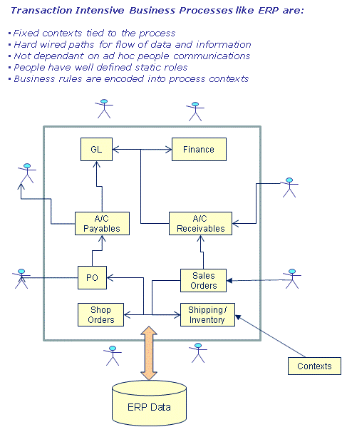
The end effect of ERP styled automation has been to eliminate high friction interaction activities like sending memos for process driven activities such as order taking and fulfillment, or informing accounting about the activities so that the money transactions can be completed. This was possible because the nature of the activities were extremely repeatable and there was little, if any, need for human judgment at each of the contexts – whether functional/departmental or whether they were related to customers/vendors/ orders/people. The industry is constantly squeezing out labor required for routing while retaining the points at which judgment is required. Pushed to its limits firms will end up squeezing as much of the labor for coordination, distribution and logistics of information; and the resultant system will begin to appear like the ERP model where the residual people may be employees or external contractors. This is further evidence of Ronald Coase’s theorem about the total cost of transactions being the decision point for when a firm is needed to produce goods or service; however we are introducing the concept of a mechanized information management system that all external stakeholders in the value chain and the residual internal employees need to work with. This is something that industries will keep seeking and today we confront the nature of tacit interactions to look for opportunities to remove interaction costs. The big challenge is to replicate an ERP type “tacit information logistics automation” so that the decision making knowledge worker is now able to focus on the core business of finding oil, developing drugs or technology, and crafting investment deals – instead of worrying about how to organize emails and where to put documents away. One lesson we can take from this past experience is that the friction that transactional and transformational industries eliminated relates to:
- Communicating data, information and metadata
- Organizing all the above information contextually, and equally importantly –
- Finding the information when needed.

Nature of interactions at a tacit interaction heavy enterprise
In today’s enterprise we need to confront two additional imperatives:
- Security: The network which eventually connects to the general internet cloud and the extraprise that depends on a community of external parties to complete their business purpose requires a very high level of security applied in real time not only on people, but also on the applications and data.
- Compliance: The need to apply rules around the decisions being made throughout the company and to report any deviances that affect the company materially. These rules have the power of board accepted policies and prevailing laws such as Sarbanes-Oxley, FASB, and SORP in the UK.
This digression to understand the evolution of transactional and transformational business to their modern day state was important because of the lessons that can be learnt; and because the differences between those businesses and today’s tacit interaction heavy businesses can provide us vital clues in defining the organization structures that will work and what will not work.
Tacit interactions heavy businesses find it very difficult to remove (or in consulting language – dis-intermediate) the people from internal facilitation and maturation (progressing assets through a process to improve its value) because unlike in transactional or transformational businesses, their work requires experience, knowledge, skills, and judgment. Email and other forms of communications are important – however unlike the memos of an earlier era, these are not highly codified messages – rather they are likely to be insightful, and subjective. The kind of internal emails that the informal network of thoughtful people trying to avert the Columbia disaster are examples of this type of tacit interactions. This difference is a point of departure from how the other businesses evolved. Activities such as innovation are not a result of structured processes, or even habits of thought or behavior. They are intrinsic to the complex nature of thought and probity and liberal interaction among people with diverse ideas and ways of thinking. This implies that tacit interactions must be analyzed with a view of optimizing it without the possibility of removing (dis-intermediating) people in the loop of the decision making activities. Steve Job, hailed by most to be one of the most innovative and inspiring leaders of industry did not rely on a formal committee based invention of the iPhone. He formed a very tight small team – another way that a social network manifests itself. With his strong core, and incredibly good designers and a web of suppliers who worked with them in the real organization set up to execute the development of this device, a game changing idea was realized. This is an excellent example of how real organizations and social networking can inter-twine and its participants collaborate. The goals or purpose was always defined, but instead of an open loop “plan the work – then work the plan” approach they were able to achieve the purpose which the real organization was established while tapping into the informal network of idea generators and problem solvers. The the challenge is to create an information management schema that makes real organizations truly effective and being able to tap into the value of the informal organizations so that they enable:
- Communicating data, information and metadata
- Organizing all the above information contextually
- Finding the information when needed
- Security, and
- Compliance

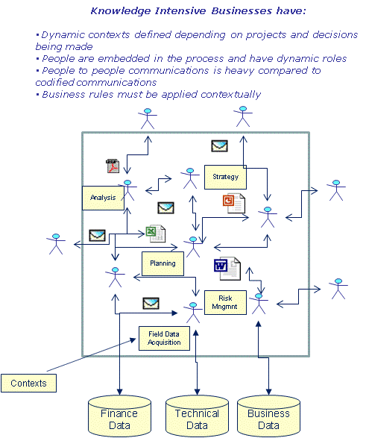
Interactions within the real organizations will be naturally purposeful. Schedules of the specific project, and tasks within it trigger activities; while the purpose or objectives of each task drive the kind of work that needs to be done or the collaboration that is required for each context with extreme clarity and total immersion for its participants. The resulting communications that actually occur among the people involved are all contextual and very specific to the project and its tasks. If each communication is parsed and analyzed in terms of their related business context, the contexts will look like a communications network and the hot spots will relate directly to the currency and state of the contexts in terms of the schedule and inter-dependence. So far as the business is concerned, and the specific projects within them, this is the network that provides the real measure of the state of the projects (or actual work).
The informal organization or social network, on the other hand, is a people to people network (Robert L. Cross April 2007). A specific task might trigger an individual to tap his network for some guidance from someone who is seen as a mentor; or a specialist such as a geologist on a project might want to double-
check a finding with her trusted colleague even though the colleague is not billed to the project. The CAIB report showed how deep and powerful some of these networks can be – ripping through bureaucracy couched as process; providing insights into problems that cannot be easily solved; seeding innovation; and sparking invention; and identifying serious risks and figuring out how to mitigate them rapidly.
Activities within social networks tend to be more self-motivated, and only loosely related to the contexts within the real networks - unlike real networks where the contextual schedule and purpose is the key motivator. Social networks are least likely to be related to initiatives and directives from the formal organization. It might be a cynical view, but social networks are a human way to counter the regimen and banal formality. It does take a special kind of person who is more likely to break the formal chain of command and look for people that can be trusted, who know, and who will contribute in an environment without fear of every thought or comment being a career defining moment.
The Roger’s report on the first Challenger Report has an addendum by Richard Feynman (Feynman June 1987) that considers the failure of management to appreciate the wisdom of the informal network of engineers from NASA and the manufacturer of the booster rocket. Feyman says, “It appears that there are enormous differences of opinion as to the probability of a failure with loss of vehicle and of human life. The estimates range from roughly 1 in 100 to 1 in 100,000. The higher figures come from the working engineers, and the very low figures from management. What are the causes and consequences of this lack of agreement? Since 1 part in 100,000 would imply that one could put a Shuttle up each day for 300 years expecting to lose only one, we could properly ask "What is the cause of management's fantastic faith in the machinery?" … later in his conclusions he notes, “Official management, on the other hand, claims to believe the probability of failure is a thousand times less. One reason for this may be an attempt to assure the government of NASA perfection and success in order to ensure the supply of funds. The other may be that they sincerely believed it to be true, demonstrating an almost incredible lack of communication between themselves and their working engineers”.
Formal organizations seldom learn from this kind of explicit advice. NASA repeated its foolhardy lack of consideration of reality and replaced it with rationalization as they launched and then failed to attempt to correct the problem with the ill-fated Columbia. Companies engaged in tacit interactions today, in upstream exploration for oil, or developers of drugs, commit such institutionalized errors that cause them to overlook opportunities or risks.
Formal organizations inhibit free flow of ideas. That is not all bad – there are organizations that need controlled flow of information because of the nature of their mission. The military is an extreme example where the formal organization is dominant. Military interactions within the formal organization are usually known as C4I(Command, Control, Communications, Computers, and Intelligence) – where command refers to the organization and the roles (rank) structure; control is the authority assigned to the roles to give orders and the obligation of the rank and file to obey those orders down the chain of command; Communications refers to the vital communications required for effecting the orders; Computers is the decision supports systems required to provide command and the recipients of the command with the strategic, tactical and operation picture of their working scenario, or to prepare for them; and Intelligence refers to the data and information gathered about their operating environment. Businesses that rely on tacit interactions are not consistent with a military organization. Coincidentally, transactional and transformational organization with a high level of automation will tend to mirror the military interaction model except the Intelligence component. Even that is being rapidly incorporated through Business Intelligence and Competitive Intelligence capabilities that they are acquiring.
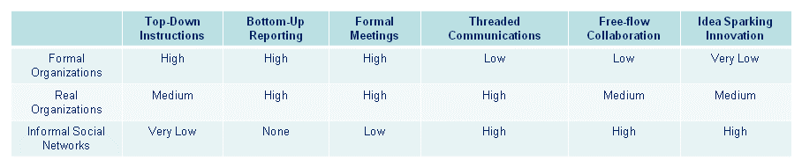
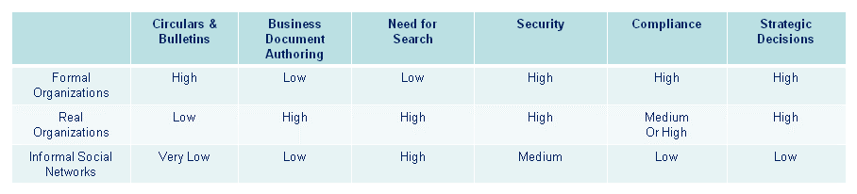

The relative importance of roles, the people that assume those roles, and the business contexts for which people assume roles are different in each of the three organization types. The importance of each of these components is shown in the table below.
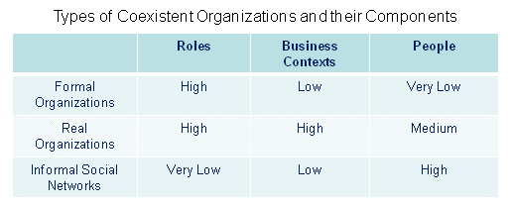
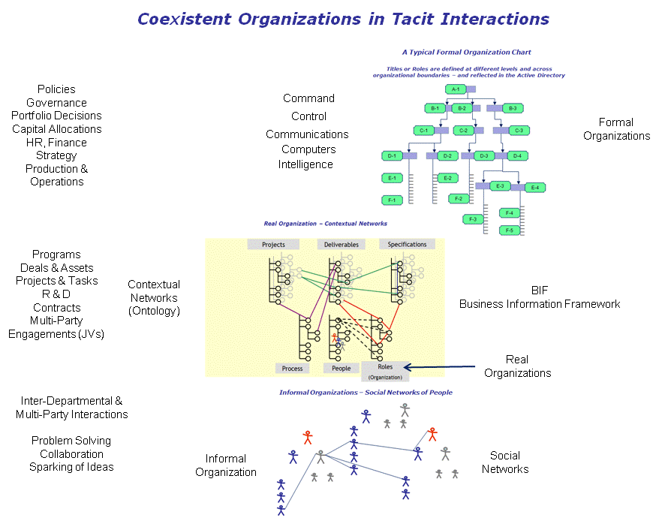

Information and its intersection with organizations
Information and the flow of information caused by the activities of people or processes drives knowledge intensive, decision centric businesses. Information systems for tacit interactions heavy businesses should promote the following as part of the basic infrastructure related to information:
- Communicating data, information and metadata
- Organizing all the information according to the business contexts
- Search - Finding the information when needed
- Security, and
- Compliance
While the first three in this list were discusses in terms of the nature the real organizations and the informal organizations, the last two are essential to corporate governance and basic security of the company.
The real organization is both a network of business contexts as well as a set of hierarchies for each project. This contextual network is intrinsically scalable as new projects come and old projects get completed and their records archived. Business contexts can be organized into a tree representing a project or a process. It may be used to represent other aspects of business including functional organizations; or the activities of a legal department; or a committee; or even the table of contents of a complex document being co-authored by many people. These separate trees may be linked across contexts from different trees to represent the nature of their inter-dependencies or communications. The composite structure forms the skeleton or framework for the company’s view of its business. If applied departmentally, this structure or framework represents the entire department’s view of its work and its knowledge.
In a contextual framework (Business Information Framework – BIF) every context has its own content such as emails, documents, and data as well as – potentially – access to applications that can create or read the data and documents. This is a very different model from that used today in enterprises – where applications “rule”. None of the discussions thus far about making tacit interactions effective have shown any need to break out the enterprise in terms of “applications”. The fact is, though, that is exactly what has happened in industry. It is the equivalent of, say, the home construction industry organizing its contractors and its building process, its drawings systems, and permits around tools. So contractors would advertise themselves as being in the “roofing-hammer” practice or 4” brush painting practice, or the pipe-bending practice – as opposed to being in the roofing business, painting business, or plumbing business. Yet – that balkanized view is precisely how things have developed in the information technology world. It is high time that it is brought out of the application centric view to a meaningful contextual –view which is always aligned with the business view of “what” it is that must be done (as opposed to “how” or what tool do we do it with).

The EAI (Enterprise Application Integration) initiatives of the past decade are a classic example of how this application centric view skewed thinking by the specialists and consultants. Again, taking a leaf from the ERP evolution, the industry set out to integrate disparate applications, forgetting that the true integration point is actually the business topic and not the applications themselves. Sure, at some point the data from one application (or tool) needs to flow seamlessly to another application to meet business requirements. However, in transactional and transformational business these types of integrations would work after a fashion because there are no residual people in the loop after the exercise in automation (as the earlier figure shows). But business which are heavy on tacit interactions find such generic integration very difficult if not impossible because all possible use cases cannot be considered a priori and people will make decisions that may require information from multiple applications without piping information from one to another application. It is also very commonplace for different combinations of applications to be called for on a business context based on the specific needs of the real project.
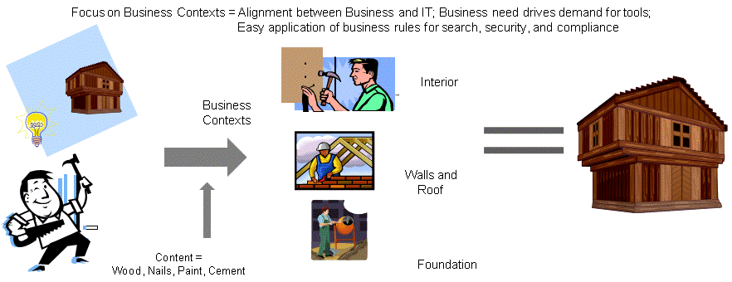
The diagram shown below represents the nature of contextual networks, which tend to expand in small spurts as each project is instantiated. Many similar, but not same, projects can be instantiated at the same node – as in the case of a process for managing projects or deals. Each project – represented by a star network, can have multiple levels of additional contexts below them. Each node has multiple roles associated with it, and a library of disparate content types, as well as access to applications needed to manage the information needed at the context.
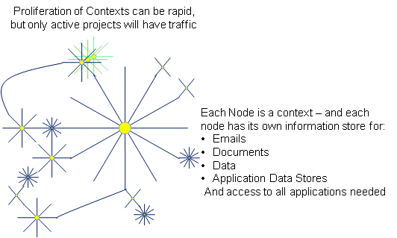
The following stack, which we refer to as an Ontology Engine represents this Real Organization completely. When the contexts are primed with its content, and connected to their roles – which in turn is connected to the people; which in turn is connected to their expertise and experience information; and the contexts and content (or data stores are connected to the applications; all of these are linked to definitions in taxonomies – then we have completely represented the knowledge of the department, or enterprise. The Ontology, we argue is the right way to organize information – whether manually or automatically by applications.
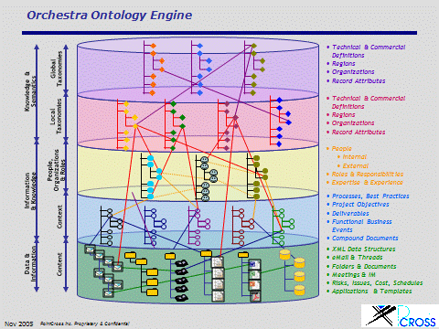
The company builds its knowledge and the communications among these contexts traps the changes and buildup of the corporate knowledge. In today’s enterprise there is virtually no content that is started and completed outside of the digital cloud. The Ontology, as shown above, is designed to capture everything from the simplest email to the most complex structured document from its start to completion. Any content of any worth is not just created by its authors for their personal reading pleasure, but it is shared or published – otherwise there is little point in spending that effort. That should be captured either into the context in which it was created or when it was distributed in emails or other ways. There is no point whatsoever in capturing content in digital libraries – other than to use these applications as file storage. There is also no point is letting the application define its data store.
In enterprises communications occur:
- Among people to set up, negotiate, or clear logistics related to a business event such as a meeting, travel, or even agreeing on a ride home. There is also the odd joke of the day or observations on some new policy or the other. These have no serious relevance to business purposes; nevertheless they are real – and although there is no real need to record these for business purposes; they could be subject to compliance and records retention rules.
- By people occupying roles in real organizations to further the business of the company as they work in various business contexts. They may communicate with others who occupy the same or other contexts in the same (real) project or another project. They may even communicate with people outside of the enterprise such as contractors or vendors. These are very important contextual communications of a real organization. These communications occur on behalf of their roles in the project and the access privileges they are assigned. Without exceptions all of these communications should be captured within the context (or in association with the context). In a contextual network or a real organization; organizing these communications and their attached payloads directly within the context can be a lifesaver when solving prickly problems. Although we tend to think of email as a primary form of communications within real networks (over 75% of all information in a company moves through email) there are other media for communication that should be considered in exactly the same way – Instant Messaging (IM), Voice over IP which is replacing the plain old telephone in most enterprises; and even video. As the infrastructure vendors unify these disparate messaging systems enterprises should take advantage of it and also incorporate them into the unified business information services for these real organizations.
- By automated processes that consume data and information from some contexts in a project or provide decisions and information to other contexts. The differences between communications explicitly crafted by a person or an automated system is beginning to be blurred and as processes take root to augment tacit interactions (see diagram on tacit interactions) people will receive automated messages in various forms – such as in dashboards, remote alerting systems, and of course the email.
Two dramatic changes happened in the mid nineties – people switched en mass to email and they got very comfortable with the convenience and speed. Secondly, enterprises threw out more than two centuries of best practice – that of first registering all memos and contextualizing it (discussed earlier) before making it available to the recipients.
The former increased productivity and reduced the latency in communications all across industry. That was great. The latter caused a complete loss any centralized or even departmental record keeping leading to patchwork solutions like electronic libraries, and record management systems that require the documents and contents of communications to be taken by people, after they received or sent the email, to “go put it away” according to various policies. Sure – that goes down well with business people; and it is not difficult to imagine there is serious lack of adoption. In truly mission oriented real organizations we have typically seen less than 15% of all the content ever being placed into the records management system or document management system. A super major US oil company reports that their knowledge workers spend over 3 days of productive time per month on trying to organize information – or an equivalent of 7,000 employees across the company. This problem can be painlessly reversed by contextualizing information, keeping a minimum number of unique copies (preferably one copy!) and making sure that the capture is automatic and without latency.
The last of the three elements that contribute to reducing the transactional costs within the organization is search. Search has been an outstanding success in the consumer world and it is transforming the way we deal with publicly accessible information. Within a firm however, search is a different matter altogether. About half of the 75% or more time that people spend on tacit interactions is considered to be looking for the right information. For a typical worker, it may begin with something in an email, which requires searching through thousands of emails using keywords. That in turn might require looking through local file folders or shared drives on the servers. There are a number of desktop search engines that can detect emails and documents. But search on the intranet is still elusive. Today only archived or published content and documents can be searched.
But people working on specific projects n the real organization do not have much need for moth-balled documents from yesterday’s projects. They need information about their own projects or other projects that have relationship with theirs. People assuming formal roles have less need for search because they tend to rely on the circulars and reports for their information usually delivered to them just in time. People participating in the informal organization (or social network) are very likely heavy users of search and they are likely to use them more effectively. Finding information and connecting people are the kind of activities that make social networks effective.
For search to be effective, people must be able to:
- Search for and find information, that they are authorized to see, which are contained in emails, documents, data or the meta-data of their accessible content
- Trigger workflows in the background that might make background requests from information owners if they cannot view them directly. This kind of blind search is not only valuable but it also promotes the creation of an effective informal organization.
- View the results contextually. This means consolidating results around the business contexts managed by the real organization. Unlike consumer search where the context and the concepts within a document must be gleaned from the text by the search engine, enterprise search should display its results in the same contexts that people can recognize through their work. These contexts provide the gateway into related information
- Conduct their search from their perspective, or also referred to as “directed search” (Jaime Teevan 2004 April, Vienna, Austria ). Search can take many different paths as the user drills down from a keyword to a set of resulting contexts, to people or their expertise; or the user
- There are no sources in the current document.might jump projects into another to discover an expert who might be able to collaborate with the user.
- As the distinction between people and applications blur in a unified information system, applications must be able to trigger search services
A larger goal is to think about search beyond the simplistic finding of documents that have search terms entered by the users and consider ways to bring to the notice of the users those contexts with likely data and information that will help the user gain a better perspective about her current state of understanding and point to areas that she might not have considered.
Information security and compliance go very well hand in hand. Both can be treated exactly the same way provided the infrastructure is architected contextually. A contextual, ontology based architecture can serve both purposes uniformly and easily. Security and compliance requires fine grained roles and responsibilities that authorize the kind of activities that are assigned to individuals. Both are associated with content that the users access or distribute. Both require that the decisions made are logged and made available for audit tracking. Both require that business rules are applied to automatically permit or prohibit the distribution of content. The application of security or compliance rules at the application level poses great difficulties such as scalability, the need for business users to provide specific attributes for each document, or email, so they may be treated correctly; and the complexity of organizing information according to the business context.
Departments or enterprises engaged in heavy tacit interactions can benefit greatly by having an information system that is capable of organizing and communicating business information contextually rather than the current disparate ways in which emails and documents are managed. They can also benefit greatly from the intrinsic unification of disparate information around related business contexts so that permission, distribution, and records level attributes are applied at the contextual level rather than at the piece level email by email or document by document.

Bibliography

Beardsley, Scott C. "Competitive advantage from better interactions." McKinsey Quarterly ., 2006 Number 2.
Bryan, Lowell L. "Harnessing the power of Informal employee networks." McKinsey Quarterly ., Q4 2007.
Coase, R. H. "The Nature of the Firm." 1937.
Jaime Teevan, Christine Alvarado, Mark S. Ackerman and David R. Karger. "The Perfect Search Engine Is Not Enough:A Study of Orienteering Behavior in Directed Search." CHI 2004 Papers, 2004 April, Vienna, Austria : Vol 6, #1.
Madhavan, S. "Unifying Business Information for enabling Search, Security, and Compliance – Section 2: Problems with Access Control of Business Information in Modern Enterprises." PointCross inc. Papers, 2007, September.
Robert L. Cross, S. P. "The role of networks in organizational change." McKinsey Quarterly , April 2007.

BIF – Business Information Framework is the name coined by Shell EP

